## Time Synchronization Subsystem

### Time Server

The LANTIME (Local Area Network Time Server) provides a high precision time base to a TCP/IP network (Stratum-1-Server). The NTP (Network Time Protocol) is used to synchronize all NTP clients with the reference. The several LANTIME variants differ from each other by the time reference and output configuration. A GPS or GNSS (GPS, GLONASS, Galileo, BeiDou) receiver, GNS-UC (only GPS and Galileo), a long wave receiver (like DCF77, MSF or WWVB) or an IRIG time code receiver can be integrated as an internal reference as well as a combination of these references (hybrid system). External references are also possible.

The LANTIME system is a set of equipment composed of an integrated GPS receiver, a single-board computer and a power supply, all installed in a metal 19-inch modular chassis and ready to operate. A simplified

LINUX operating system is installed on the single-board computers flash disk. Eight push buttons and a display can be used to configure and monitor the time server.

After the network connection has been established the time server can also be configured and monitored remotely from a workstation via TELNET or FTP. An integrated web server enables access to the LANTIME by using an ordinary web browser. 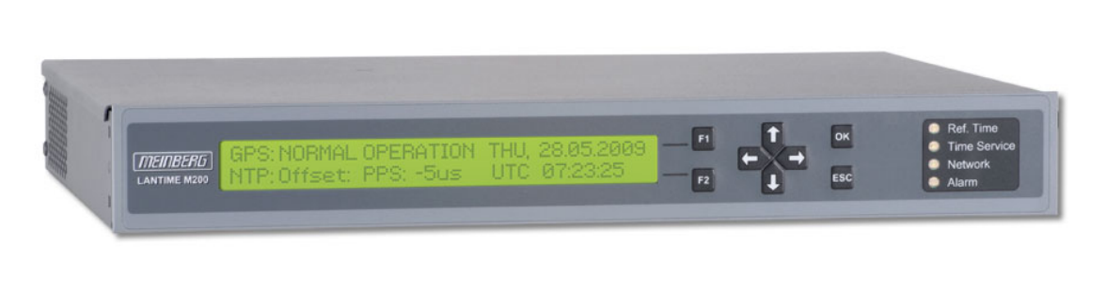

*Figure 5‑8 Time Server Meinberg Lantime M200*

|  |  |
| --- | --- |
| Characteristics | Description |
| Display | LC-display, 2 x 40 characters, with backlight |
| Control elements | Eight push buttons to set up basic network parameters and to change receiver settings |
| Status info | Four bicolor LEDs showing status of:  - reference time  - time service  - network  - alarm |
| Network Interface | RJ-45 Network Connection 10/100 MBit |
| Universal Serial Bus (USB) Ports | 1x USB Port in rear panel:  - install firmware upgrades  - backup and restore configuration files  - copy security keys  - lock/unlock front keys |
| Power supply | Standard: 100-240 V AC (50/60 Hz)  available DC variants: 100-200 V DC, 12 V DC and 20-60 V DC |
| Power consumption | 20W |
| CPU | AMD Geode |
| Operating System of the SBC | Linux with nano kernel (incl. PPSkit) |
| Network protocols OSI Layer 4 (transport layer) | TCP, UDP |
| Network protocols OSI Layer 7 (application layer) | TELNET, FTP, SSH (incl. SFTP, SCP), HTTP, HTTPS, SYSLOG, SNMP |
| Internet Protocol (IP) | IP v4, IP v6 |
| Network Time Protocol (NTP) | NTP v2 (RFC 1119), NTP v3 (RFC 1305), NTP v4 (RFC 5905) SNTP v3 (RFC 1769), SNTP v4 (RFC 4330) MD5 / SHA-1 Authentication and Autokey Key Management |
| Time Protocol (TIME) | Time Protocol (RFC 868) |
| Daytime Protocol (DAYTIME) | Daytime Protocol (RFC 867) |
| IEC 61850 | Synchronization of IEC 61850 compliant devices by using SNTP |
| Hypertext Transfer Protocol (HTTP) | HTTP/HTTPS (RC 2616) |
| Secure Shell (SSH) | SSH v1.3, SSH v1.5, SSH v2 (OpenSSH) |
| Telnet | Telnet (RFC 854-RFC 861) |
| Form Factor | 335 x 45 x 240 mm |
| Ambient temperature | 0 ... 50°C / 32 ... 122°F |
| Humidity | Max. 85% |

### SymmTime SW

SymmTime is a desktop clock. It allows to make synchronize the system clock with the Time server LANTIME M200.

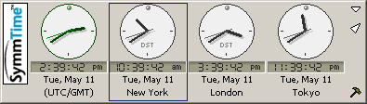

*Figure 5‑9 SymmTime Application*

It allows you to choose when and how often you want to have the time synchronized and what synchronization servers to use. It even lets you view a detailed report of the synchronization status. Additionally, the app allows you to view the time in any timezone and it can be set to display multiple clocks.

If you right-click on a clock in your SymmTime panel, this menu displays. The menu options are detailed here.

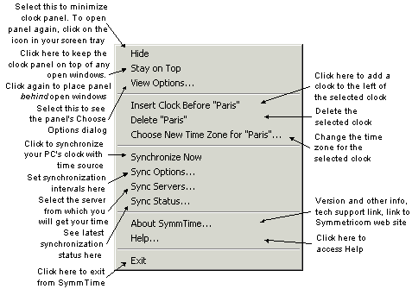

*Figure 5‑10 SymmTime Menu*

This option on the right-click menu tells your SymmTime when to synchronize (at selected intervals) with the server, and what the maximum adjustment threshold should be. Also, you can direct SymmTime to retry syncing if at first there is no response.

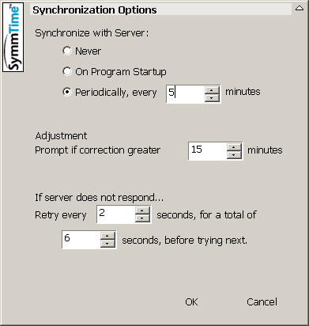

*Figure 5‑11 Sync Options*

This option on the right-click menu lets you see the servers your SymmTime is actively using, as well as unused servers that you can add to your active list.

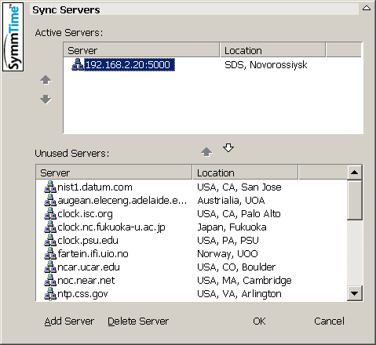

*Figure 5‑12 Sync Servers*

This option on the right-click menu shows you the time of the last synchronization and the next along with recent history.

### TIMESERVER application and TIMESYNCCLIENT service

For the organization of all servers, computers and electronic devices time synchronization is used synchronizing component from the Navi-Harbour software package, which includes **TIMESYNCSERVER** and **TIMESYNCCLIENT** software.

**TIMESYNCSERVER** application installed on VTS Server virtual machine. **TIMESYNCSERVER** uses VTS Server system clock as a source of the accurate time for time synchronization.

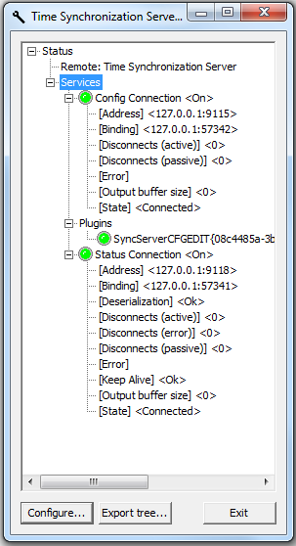

*Figure 5‑13 Time synchronization server*

**TIMESYNCSERVER** program run with the following parameters:

|  |  |  |
| --- | --- | --- |
| **Parameter type** | **Description** | **Default value** |
| <name>.ini | Name of ini file in use | SyncServ.ini |
| /x | Use IPX protocol | Use TCP protocol |
| /s<socket number> | IP port number which does not conflict other IP port numbers used in this computer | 5000 |
| /p<number> | Period of sending synchronized messages | 10 sec |

**TIMESYNCCLIENT** service (**SyncClient**) installed on each server, virtual server and computer in VTMIS system except VTS Server 1 and 2. **TIMESYNCCLIENT** service (**SyncClient**) uses **TIMESYNCSERVER** application installed on VTS Server 1 and 2 as a source of accurate time for time synchronization.

To make sure the TIMESYNCCLIENT service program installed properly and running in the following way, it is necessary:

Open Task Manager by right-clicking the taskbar, and then clicking **Start Task Manager**.

Click the **Services** tab to see a list of all the services that are currently running on your computer and find TIMESYNCCLIENT service by name **SyncClient.**

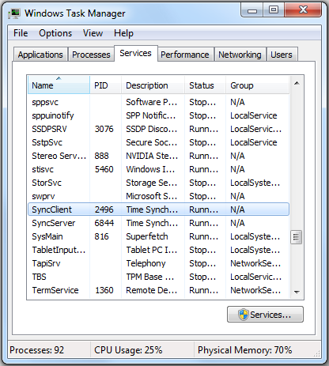

*Figure 5‑14 Time synchronization client*